**INSTRUCTIONS TO SUBMIT YOUR TRANSCRIPT FOR THE PD STIPEND**

STEP 1: Make sure you have entered all your PD hours into AVATAR. For classes that you did not register for on AVATAR, please follow the instructions on how to input them onto your transcript.

STEP 2: Click on My Transcript on the left hand column of the screen.

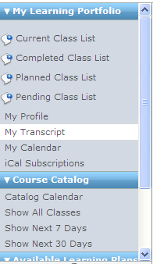

STEP 3: Click on the printer icon in the upper right hand corner.

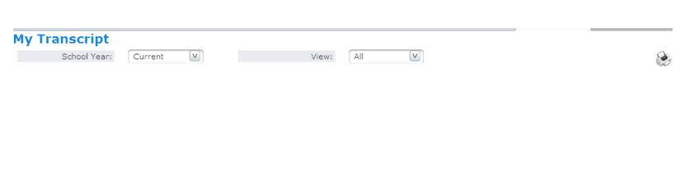

It’s a good idea to make sure this says current as well. Usually does!

STEP 4: This should bring up a new window. If there are courses that showed up on AVATAR that are not showing up on the new window, that means that you need to go back to step one for those courses.

STEP 5: Submit the transcript to Andrea Seckel (keep a copy of your own) by May 31, 2013.